Support Our Work!  We are a 501(c)3 Non-Profit Organization and all donations, no matter how small or large, are tax deductible.  Donate Today!  Billing Information:  First Name: ___________________________  Last Name: ___________________________  Address: _______________________________  City: __________________________________  State: ________________________________  Phone Number: ______________________  Email: ______________________________  Amount: ___________  Name On Card: ________________________  Card Number: _________________________  Security Code: __________  Expiration Date: ___________  You can also donate through PayPal on our Website or write a check addressed to Women And Family Ascending Association! | Who We Are  About Us  We are a nonproﬁt organization that helps families and/or individuals through various social programs  to clients of all cultural backgrounds.  Contact Us  Phone: 973-766-2406  Email: wafaa@wafaaorganization.org  Web: www.wafaaorganization.org  Follow Us On Our Social Media:  Twitter: @WafaaSaad3  Facebook: @wafaaorganization  Instagram: wafaaorganization  Youtube: Wafaa Saad  Women and family ascending ASSOCIATION (W.a.f.a.a.)  P.O. Box 3302  Wayne, NJ 07474   | Women and family ascending ASSOCIATION (W.a.f.a.a.)  - Paving the way today for a better tomorrow!
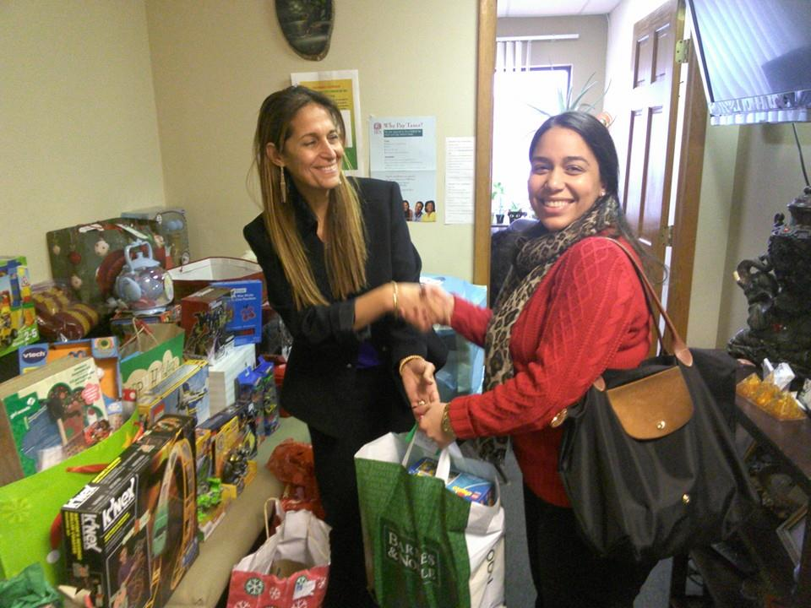    Our founder Wafaa Saad handing out toys to one of our supporters.  Our Mission Statement: Our Mission is to End Domestic Abuse and Empower Individuals by Providing Protection, Education and Resources.  To that end we have helped hundreds of individuals and we have worked with and are recognized by:  • Passaic County Board of Freeholders  • Passaic Family Court  • Saint Joseph’s Healthcare System  • State Senators & Congressmen  • New Jersey’s Parent Foundation | Testimonials  Testimonials  “Wafaa sat with my daughters and me at the court house and court room. She visited me later in the hospital when I was injured. I’m glad she was in my community” – Donna Ivery  “WAFAA also informed me about rights that I was not aware of. She connected me with services and lawyers. Thank you WAFAA for all the help you have offered me. Thank you.” -Rabeaa  We value our volunteers and interns who truly help make this organization so successful. Any person can volunteer and if you are a student, you can intern with us for College Credit and potentially be paid through Federal-Work Study.  If you are interested, send us an email or call us and we will be happy to have you on our team! | 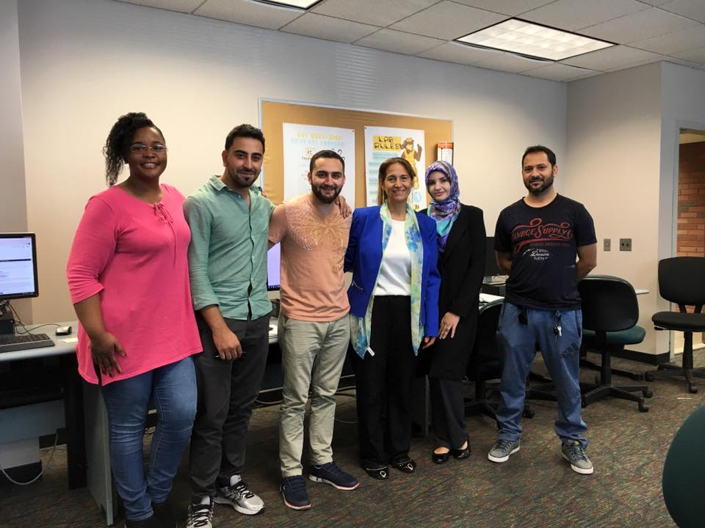  Our student interns and volunteers who make this organization work!  Here at W.A.F.A.A. we offer a variety of confidential services to help those in need. No matter who they are, we always lend a helping hand.  Our Products and Services  • 24/7 Crisis Hotline  • Crisis Intervention Therapy  • Legal Assistance  • Food Pantry & Shelter  • Anger Management Therapy  • Immigration Paper Work  • Referrals for Assistance  • Notary Public  • Bill & Insurance Assistance

