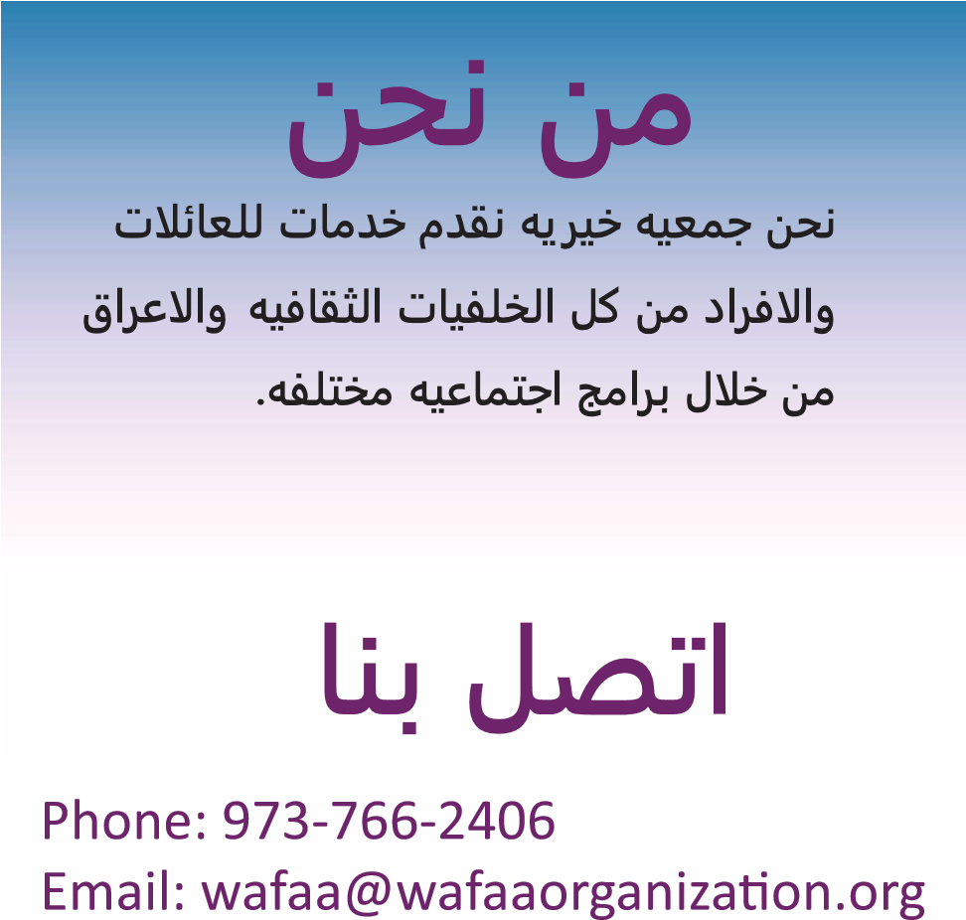

|  |  |
| --- | --- |
| First Name: ______________________  Last Name: ______________________  Address: __________________________  City: _____________________________  State: ___________________________  Phone Number: __________________  Email: _________________________ |  |

|  |
| --- |
| **WOMEN AND**  **FAMILY**  **ASCENDING**  **ASSOCIATION**  **(W.A.F.A.A.)** |

Amount: ___________

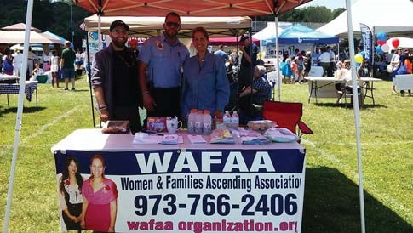

**WOMEN AND**

**FAMILY ASCENDING**

Name On Card: ___________________

Card Number: ____________________

Security Code: __________

ǆƉŝƌĂƟŽŶĂƚĞ͗ͺͺͺͺͺͺͺͺͺͺͺ

WĂǇƉĂů

ǁǁǁ͘ǁĂĨĂĂŽƌŐĂŶŝǌĂƟŽŶ͘ŽƌŐ

Women And Family

ƐĐĞŶĚŝŶŐƐƐŽĐŝĂƟŽŶ͊ **ASSOCIATION**

**(W.A.F.A.A.)**

W͘K͘ŽǆϯϮϬϮ

Wayne, NJ 07474

